Use SSRS with Apache Kylin
Date: Dicember 2016
Author: Ramón Portolés, Alberto Linkedin

Intro
Microsoft SQL Server Reporting Services (SSRS) is one of most BI Tool used, easy to learn and powerfull, which can be integrated with SharePoint.
Integration of Kylin with SSRS / SharePoint can be very interested for migration / integration of existing projects without the user’s perception 

Pre-requisites
First, you need Build Kylin Cube: Quick Start with Sample Cube: With firth step of link, you can check the result cube executing:
select part_dt, sum(price) as total_selled, count(distinct seller_id) as sellers from kylin_sales group by part_dt order by part_dt
Query results:
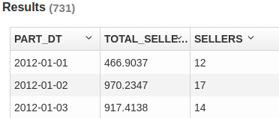

Used Software
- Kylin: 1.6.0
- Kylin ODBC 1.6
- SQL Server Standard 2012 SP3 ACU6
You can also try to use express editions with Advanced Services (ADV) : SQL 2012, SQL 2014, SQL 2016
Install Visual Studio with BI Tools:
Download SSDT-BI for Visual Studio 2013: SQL Server 2014, SQL Server 2012, SQL Server 2008 and 2008 R2
Download SSDT-BI for Visual Studio 2012: SQL Server 2014, SQL Server 2012, SQL Server 2008 and 2008 R2

Create Connection
- Install Kylin ODBC
- Add DNS System in Windows
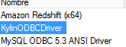
- And configure: User-name /Password: ADMIN / KYLIN
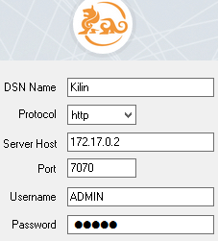
- Click Connect and Choose the project
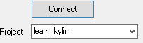

Install and configure SSRS Service
Search on Internet for more detailed steps, these notes are about typical problems / Tips
After install, check that Reporting Services and SQL Server is runing
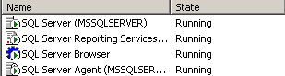

Disable UAC on your windows Windows7, 8, 10 , Windows Srv 2012

Open “Reporting Services Configuration Manager”
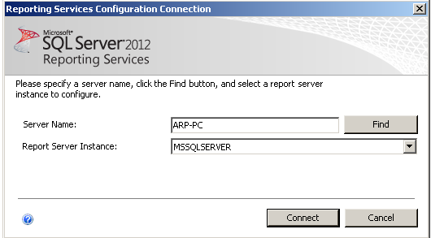

Go to  > and try to open in your Internet Explorer
using your windows Login / password:
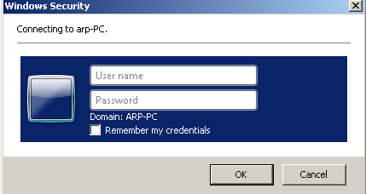

The first time you will need
- Open IExplorer as administrator !!!
- Assign your permissiona your self:
 >  > 
Insert your actual user name and check ‘System Administrator’
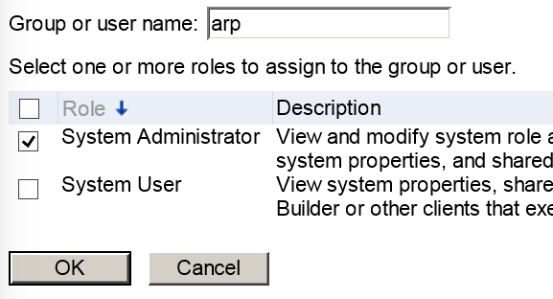
Now you can log off and enter to IExplorer without ‘Run as administrator’

ERROR: The permission granted to user are inssuficient
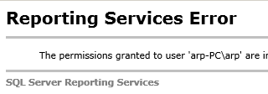

Connect to SSRS Instance using “SQL Server Configuration Manager” , using your windows credentials (now must be work, if you added your actual user as administration on install process)
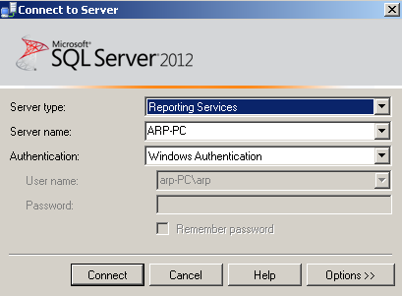

Go to permissions for administrators
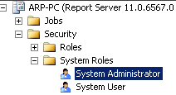

If you see disabled some options (like in picture) you dont have permission
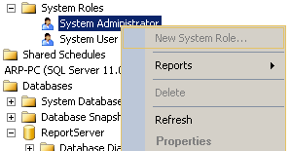

For testin pourposes, I will change the execution account of SSRS from NT autority to my local acount (not recommended for production environment), restart service will be necessary
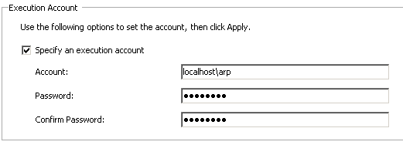

Define Kylin DataSource on Report Server Service
This configuration is a bit different of other BI tools, because you use directly the ODBC Driver, meanwhile other BI Tools use User DNS or System DNS

We put a Name to This datasource and define a type:
Write manually a connection string (perhaps other string be work OK )

DRIVER={KylinODBCDriver};Server=http://172.17.0.2;PORT=7070;PROJECT=learn_kylin

And indicate a Login / Password
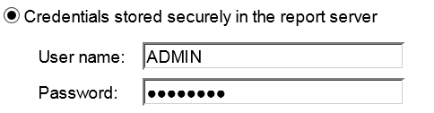

If all is OK, you will see some similar to this:


Example with Report Builder and Kylin
From Home, Click: 
Accept security confirmations:
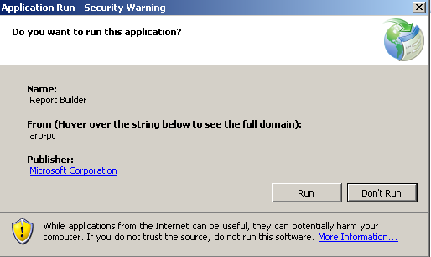

And see Welcome Dialoge of Report Buider:
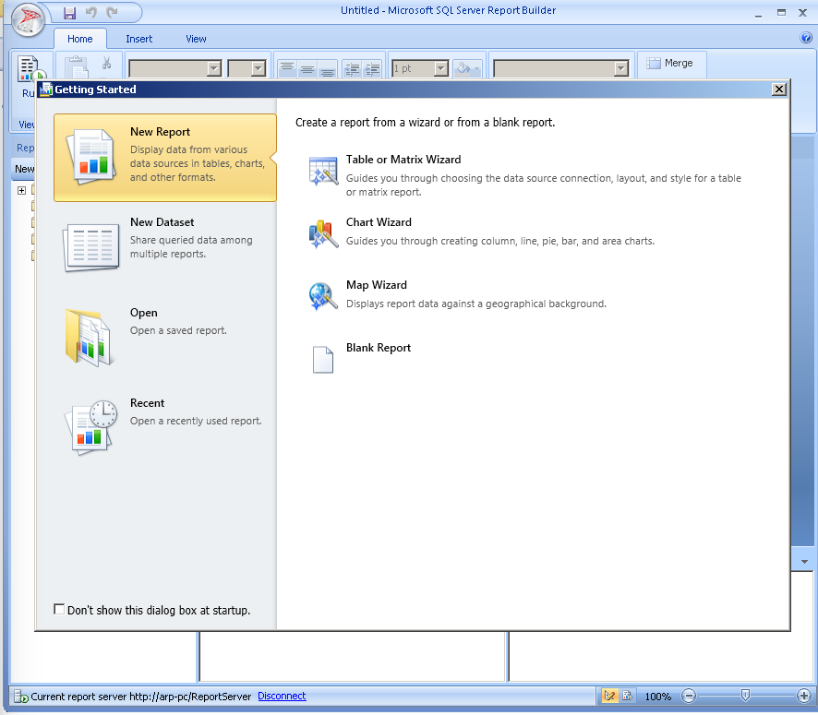
We choose 
In SSRS the general steps to make a report are:
- Define Datasource
- Define DataSet
- Define a Layaout
- Drag & Drop columns on Layaout

Add new Source:
> >
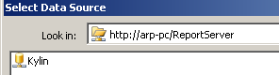

The result must be similar to this:
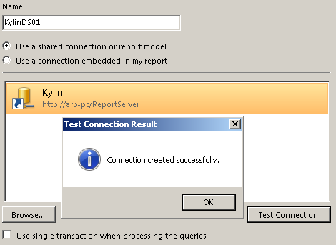

Add New DataSet FAIL !!!
Choose your new Data Source > :
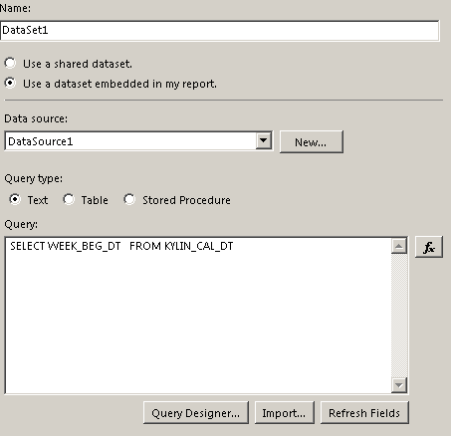
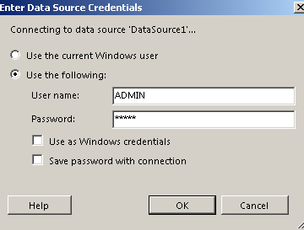
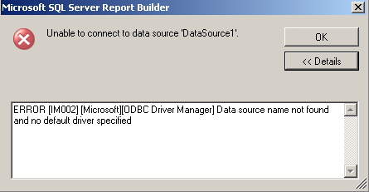

Microsoft studio data tools
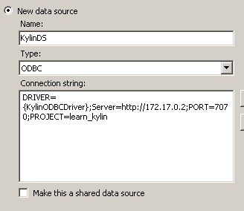
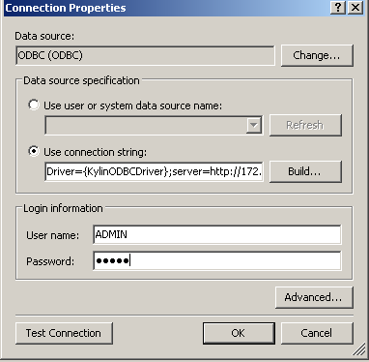
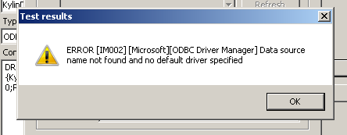
I think the problem is KylinODBCDriver is not available in Microsoft DataSources
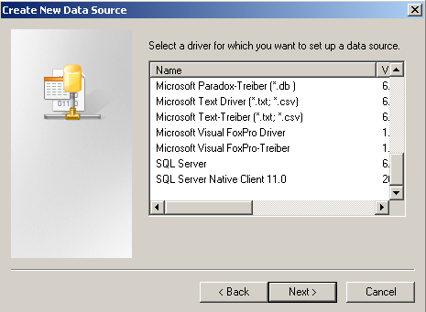

For any suggestions, feel free to contact me
Thanks, Alberto

